It’s Movie Night at the Rialto, Grayling!
Free Admission for You, Your Family, and ALL of Your Friends at the Rialto Theater in Uptown Grayling, MI.
Monday, May 1st, at 7:00 pm
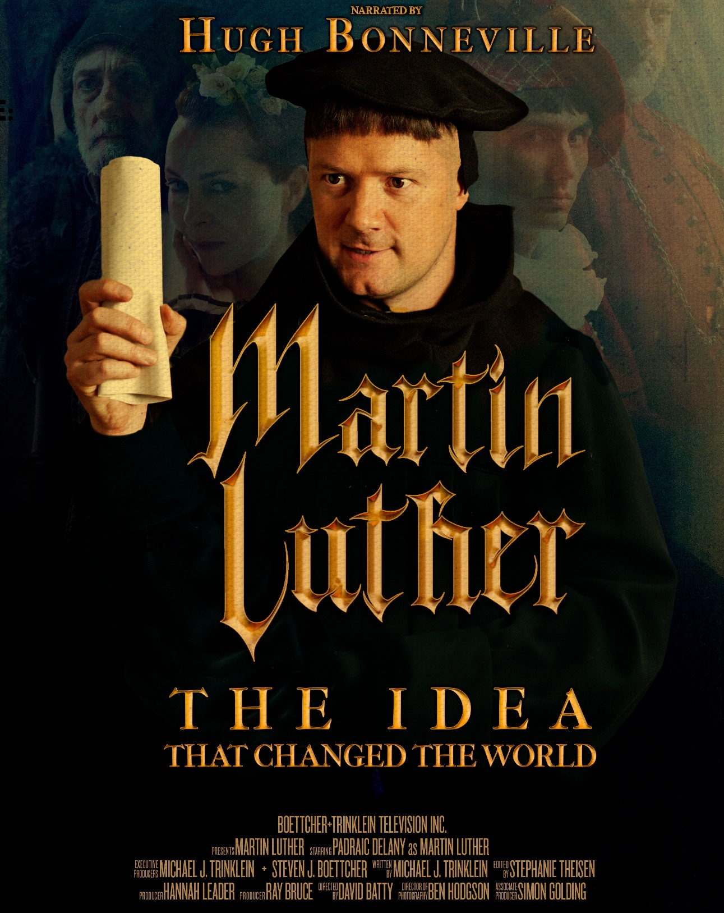
Based on the True Story, it deals with the most important questions of life, including "Who am I?" "What is my Purpose" and "How do I get right with God?"
A Brief Q&A Session Will Follow the Film

Sponsored by
Mt. Hope Lutheran Church

